[**Wiring Connections**](https://docs.platformio.org/en/latest/plus/debug-tools/esp-prog.html#id3)

| **ESP-Prog JTAG 10-Pin Connector** | **PCB Header Pin** | **JTAG Signal** | **ESP32 Pin** | **Description** |
| --- | --- | --- | --- | --- |
| 6 | 6 | TDO | GPIO15 | Test Data Out |
| 2 | 5 | TMS | GPIO14 | Test Mode State |
| 8 | 4 | TDI | GPIO12 | Test Data In |
| 3 | 3 | GND | GND | Digital ground |
| 4 | 2 | TCK | GPIO13 | JTAG Return Test Clock |
| 1 | 1 | VDD | VDD | Positive Supply Voltage — Power supply for JTAG interface drivers |

## USB configuration

1. After wiring it up, plug the ESP-Prog debugger board into a free USB port on your PC
2. Run Zadig.exe and check the “Options/List All Devices” option
3. Find “Dual RS232-HS (Interface 0)” and replace the driver with “WinUSB (v6.1.7600.16385)”
4. Find “Dual RS232-HS (Interface 0)” and replace the driver with “WinUSB (v6.1.7600.16385)”

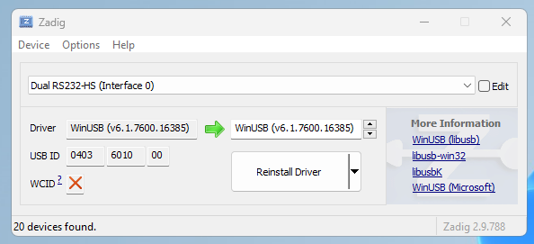

Add the following lines to platform.ini:

debug_tool = esp-prog

debug_init_break = tbreak setup

## Notes

Jumpers on the ESP-Prog board allow you to choose 3.3V or 5V output. It should match the power pin VDD is connected to on the ESP32.

To get it to update and debug successfully, I didn’t plug in the JTAG power wire to the ESP32 (the orange wire on pin closest to USB port). I can then plug in the regular USB port from ESP32 to PC which powers the ESP32.